**Senior Design 2**

MDAS.ai Drive-By-Wire Using V2X for Enhanced Safety

**System Test Report**

**Version 1 / 12 April 2019**

**Winter 2019**

Team #7 - Classified:

Athanasios Argyris, Kayleigh James, Sarah Overbeck, Joshua Quejadas

Contact Information: [soverbec@umich.edu](mailto:soverbec@umich.edu) or [aargyris@umich.edu](mailto:aargyris@umich.edu) or [jamesmk@umich.edu](mailto:jamesmk@umich.edu) or [jquejada@umich.edu](mailto:jquejada@umich.edu)

Advisor: Dr. Mike Putty

**Table of Contents**

|  |  |  |
| --- | --- | --- |
| **Section** | **Title** | **Page** |
| 1. | Introduction | 2 |
| 1.1 | Purpose | 2 |
| 1.2 | Scope and Objectives | 2 |
| 1.3 | Test Case Execution | 3 |
| 2.0 | Test Case Results | 4 |
| 2.1 | Results for Test Case 1 | 4 |
| 2.2 | Results for Test Case 2 | 8 |
| 2.3 | Results for Test Case 3 | 16 |
| 2.4 | Results for Test Case 4 | 21 |
| 2.5 | Results for Test Case 5 | 23 |
| 3.0 | Test Report Summary | 26 |
| 4.0 | References | 27 |

**1. Introduction**

**1.1 Purpose**

The purpose of this document is to describe the system test results for MDAS.ai Drive-By-Wire Using V2X for Enhanced Safety. The test report will outline the test cases, steps of execution and report results for the full system test.

**1.2 Objectives**

The system test will evaluate all aspects of the functional and performance requirements for the DbW system and major subsystems. The objective of the system test is to discern whether the system and it high-level components meet the requirements and constraints defined in the requirements specification. The test plan defines the tests that will evaluate system and subsystem performance in a quantitative and qualitative manner. Each test case definition will outline prescribed test cases for each system module with procedures intended to produce analyzable results that will concur with requirement specifications. The test report will summarize the analysis of raw data collected during the overall system test and illustrate to what extent each component under test met requirements.

The test report will detail the results from our five specific test cases which validate the entire system and confirm that it meets the requirements defined in the Requirements Specification document. The system was tested in a lab setting as that is the environment in which it must operate; this was also outlined in the Requirements Specification document.

The combination of all five test cases below will allow us to validate that all of our performance requirements have been met by the system. They are outlined as follows:

1. Normal Driving Conditions - Static Test - No message of a pedestrian in the crosswalk from the RSU, no lack of messages being sent from the joystick, no lack of control messages between modules being sent, and no input torque applied to the steering wheel by the driver. Vehicle in the lab and up on jacks.
2. Pedestrian in the Crosswalk - Message sent from the RSU to the vehicle stating that there is a pedestrian in the crosswalk ahead.
3. Wheel Turn by the Driver - The driver turns the steering wheel, disengaging DbW mode.
4. Emergency Stop - The emergency stop button is pressed, causing the vehicle to enter safe mode.

The test cases will all be performed independently. In each test case, data will be collected and an assessment will be performed to decide whether or not the requirements related to that test case has been met. The data will be recorded in an Excel spreadsheet. Each test case will have a separate sheet in order to organize our findings. The following sections contain all of the detailed test procedures and assessment criteria for each of our test cases.

**1.3 Test Case Execution**

The test cases were completed on the following dates. Due to unforeseen circumstances and delays due to facilities shutdown, the tests were completed out of the original order:

|  |  |
| --- | --- |
| **Test** | **Date** |
| Normal Driving Conditions - Static Test | April 14th, 2019 |
| Emergency Stop | April 14th, 2019 |
| No Control Messages Sent | April 10th, 2019 |
| Wheel Turn by the Driver | April 13th, 2019 |
| Pedestrian in the Crosswalk | April 13th, 2019 |

**2.0 Test Case Results**

**2.1 Test Case 1:** Emergency Stop - Testing of the E-Stop to make sure DbW disengages and brakes are fully applied within required time.

Traces to Requirements:

* Throttle requirements: 3.2.1, 3.2.2, 3.2.3, 3.2.5, 3.2.6, 3.2.7
* Steering requirements: 3.3.3
* Brake requirements: 3.4.4
* Power requirements: 3.6.1, 3.6.2
* Timing requirements: 3.7.1,3.7.2

**2.1.1 Test Case Summary:** Our first test case is the test of the emergency stop functionality. Since we are working on a full-sized vehicle, we must be extremely cautious and have safety as our top priority while testing. The Emergency Stop is the fundamental failsafe in the event of a vehicle or system malfunction so this is our most important safety feature test. The E-Stop communication is isolated from the CAN bus for this purpose.

* **Test Initialization**:

1. Unplug the vehicle from charging port
2. Put the vehicle on jacks
3. Apply manual brake to ensure it is in working order
4. Engage DbW and actuate brake system to ensure it is functional

* **Test Steps:** Once the vehicle is on initialization step 4, we will do the following tasks:

1. Apply full throttle using DbW. Once speedometer reaches 25mph, press the E-Stop.
   1. It is necessary to ensure the E-Stop safety feature is in working order, before moving onto the rest of our tests. We want the brake board to apply full brake regardless of whether it is in DbW mode or normal operation mode. We will do this by pressing the E-Stop and evaluating that our requirements were met.
2. For the first test of the E-Stop press, we measured the output analog voltage from the voltage step-down circuit to confirm that ~0V are being provided to the microcontrollers when the button is pressed.
   1. The reason why this step is important, is to verify that the analog signals coming out of the step down will be recognized by the microcontrollers and the correct response will be triggered. This step is a dual confirmation of the new input to the module boards and that the vehicle motor controller is off.
3. As the E-Stop is pressed, we used a digital oscilloscope to document the time it takes from E-Stop press to brake full actuation.
   1. Because the vehicle is on jacks, the test lacks road/terrain friction. As such, we will use the time it takes for the brakes to fully actuate as a stoppage time. Our requirements document specifies that our full stop time should be 2 to 3 seconds for a safe (emergency) stop.
   2. We connected the oscilloscope to the brake pressure sensor (BPS) and the step down circuit in the vehicle and set up triggers so that when the step-down drops to ~0V, it will read the BPS which should increase to 0.75V for full actuation. We will record the change in time (Δt) that it takes from the voltage drop of the step down to the BPS reaching 0.75V.
4. After recording the time interval, we plugged in the joystick and validated that none of the other modules are responding to inputs while the E-Stop is pressed.
   1. We need this to validate the boards are actually in safe mode. The qualitative response of the boards will be recorded, indicating no response to the messages provided to them.

* **Test Data Log:**Using an Excel spreadsheet, we manually logged the values and performed computations with the built in Excel functions. The sampling interval was for each repetition of the steps outlined above, which was completed 10 times for confirmation. The data types we will be focusing on are voltage measurements and time.

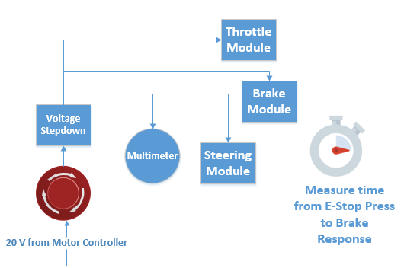

**Figure 2.1.1** - Emergency Stop Button and Module Connections

**2.1.2 Test Environment and Conditions:** The system was developed in a laboratory environment during this project. It was not be exposed to significant temperature changes, vibration, noise, or impact.

**2.1.3 Input Data Set:**If the E-Stop is not pressed, the input data set will be ≥ 0.435V output by the voltage step-down circuit connected to the solenoid voltage line to the motor controller. We will also confirm that the vehicle brakes are functional prior to commencing the test. We will depress the brake pedal manually and using the DbW system.

**2.1.4 Expected data values and results:** Expected data values for this test are actuation times from trigger to full within the range of 2-3 seconds. We expect the results from this test case to indicate that the system meets all relevant requirements. We should see ~0.435V out of the intermediary circuit when E-Stop is not engaged and ~0V when it is.

**2.1.5 Test Case Summary Data Analysis:** The test results below are outlined below. All modules are connected to the E-Stop button to ensure all boards respond appropriately.

* **Summarize data logs:** To complete this test, we set up a digital oscilloscope connected to a computer. Using Waveforms software, the voltage from the Brake Pressure sensor could be captured in real time. Our requirement specification dictates that the brakes must reach full actuation within 2-3 seconds which can be measured from the waveform. An example of the measurement taken is shown below: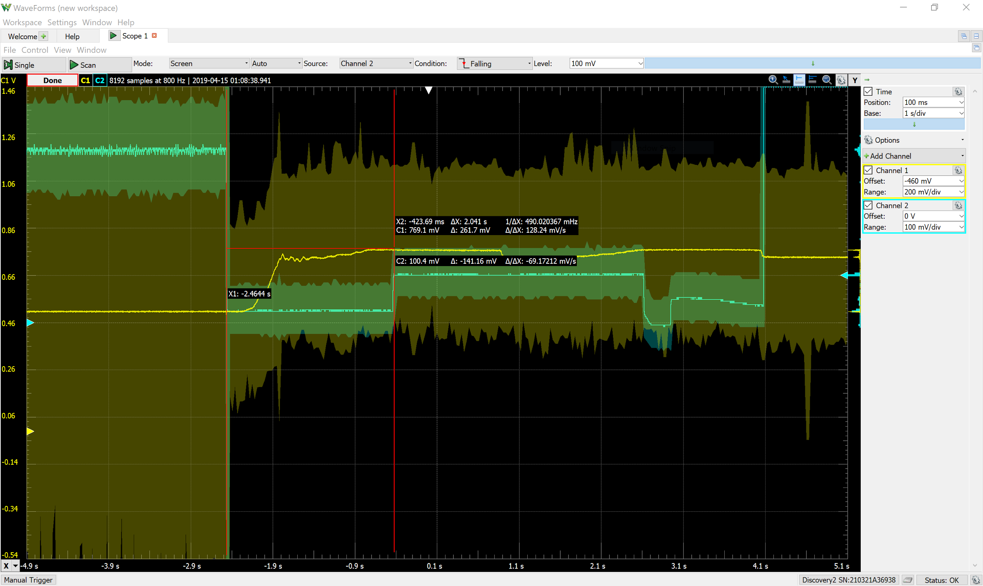

**Figure 2.1.2:** Sample BPS voltage reading - E-Stop Test

The yellow waveform (channel 1) displays the output of the brake pressure sensor. Full actuation time is measured when the brakes reach steady state. The mean and standard deviation of response time as recorded by the oscilloscope is shown in the following table:

|  |  |  |
| --- | --- | --- |
|  | **Mean** | **Standard Deviation** |
| **Full Actuation Time (s)** | 2.1154 | 0.16654 |

**Table 2.1.1:** Mean and Standard Deviation Brake Actuation Time - E-Stop

The general trend of our measurements can be seen in the following graph:

**Figure 2.1.3**: Graph of Vehicle Stop Time after E-Stop Press - Consistency Check 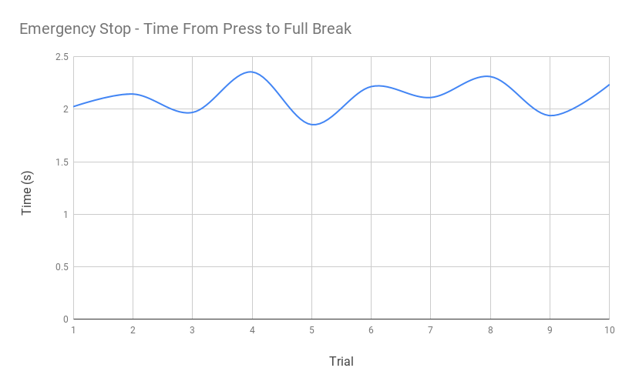

The above graph shows that while some variation exists, the full actuation time generally remains within the desired range. Shorter times can be attributed to increased grip on the brakes after several test trials.

* **Anomaly Report:** No anomalies were detected in completion of the test.
* **Suspension of Test** While initializing the test the first time, there was an anomalous, repetitive spike in the output voltage of the step-down circuit that could not be compensated for in the programming and disrupted E-Stop function. As a result, we were forced to redesign the step-down circuit to disclude the comparator. Testing resumed once the new circuit was confirmed as functional and provided adequate output voltage.

**2.1.6. Test Case Analysis**

Our requirement specification indicated a total actuation time for the brakes of 2-3 seconds when triggered by the emergency stop function. This consideration was to account for a less abrupt stop, but also quick enough in the event of an object/person in the vehicle’s path. Because our results fell within 2-2.5sec, we met this requirement.

|  |  |  |  |
| --- | --- | --- | --- |
| **Data Type** | **Test Criteria** | **Test Data Result** | **Rating** |
| Actuation Time (s) | Mean time | 2sec - 2.5sec | Excellent |

**2.2 Test Case 2** Normal Driving Conditions - Static Test

Traces to Requirements:

* Throttle requirements: 3.2.1, 3.2.2, 3.2.5
* Steering requirements: 3.3.1
* Brake requirements: 3.4.1, 3.4.2, 3.4.5, 3.4.6
* Joystick requirements: 3.5.1, 3.5.2
* Power requirements: 3.6.1, 3.6.2
* Timing requirements: 3.7.1,3.7.2

**2.2.1 Test Case Summary:** The objective of this test case was the overall functionality of the system. All the modules were tested to ensure the vehicle behaved as desired according to the control messages sent.

* **Test Initialization**:

1. Unplug the vehicle from charging port.
2. Put the vehicle on jacks for the static test.
3. Turn the vehicle on.
4. Make sure DbW works by manipulating joystick and seeing how vehicle responds.

* **Test Steps:** Once the vehicle was on initialization step 3, we completed the following tasks:

1. Check Steering (left/right steering via joystick)
   1. Use CAN to USB tool, send steering actuator to the center position
   2. Log CAN feedback for steering position sensor
   3. Send CAN message for all the way to the right
   4. Take time stamp via logged data and find Δt
   5. Repeat 10 times
   6. Repeat steps d and e for left turn of steering wheel
   7. Verify that logged CAN messages follow the message set format
2. Check Throttle (Apply more or less throttle via moving the joystick from neutral to up)
   1. Use CAN to USB tool, send 0%, 25%, …, 100% to throttle
   2. Measure DAC and half DAC voltages 10 times at each of these increments using a multimeter
   3. Log CAN feedback for throttle position sensor
   4. Verify that CAN bus feedback messages are accurate for TPS (e.g. 0% = 0 and 100% = 100) and follow the message set format
   5. Take time stamp via logged data and find Δt for 0% throttle to 100% throttle
3. Check Brake (Apply more or less brake via moving joystick from neutral to down)
   1. Use CAN to USB tool, send 0% brake
   2. Measure BPS voltage with multimeter
   3. Use CAN to USB tool, send 100% brake
   4. Measure BPS voltage with multimeter
   5. Verify 0% brake is ~ 0.511V and 100% brake is ~ 0.75V
   6. Verify CAN feedback messages with above results.
   7. Use an oscilloscope to measure Δt from 0.511V to 0.75V (0% break to 100% break) to get latency for full actuation
   8. Repeat all of these measurements 10 times

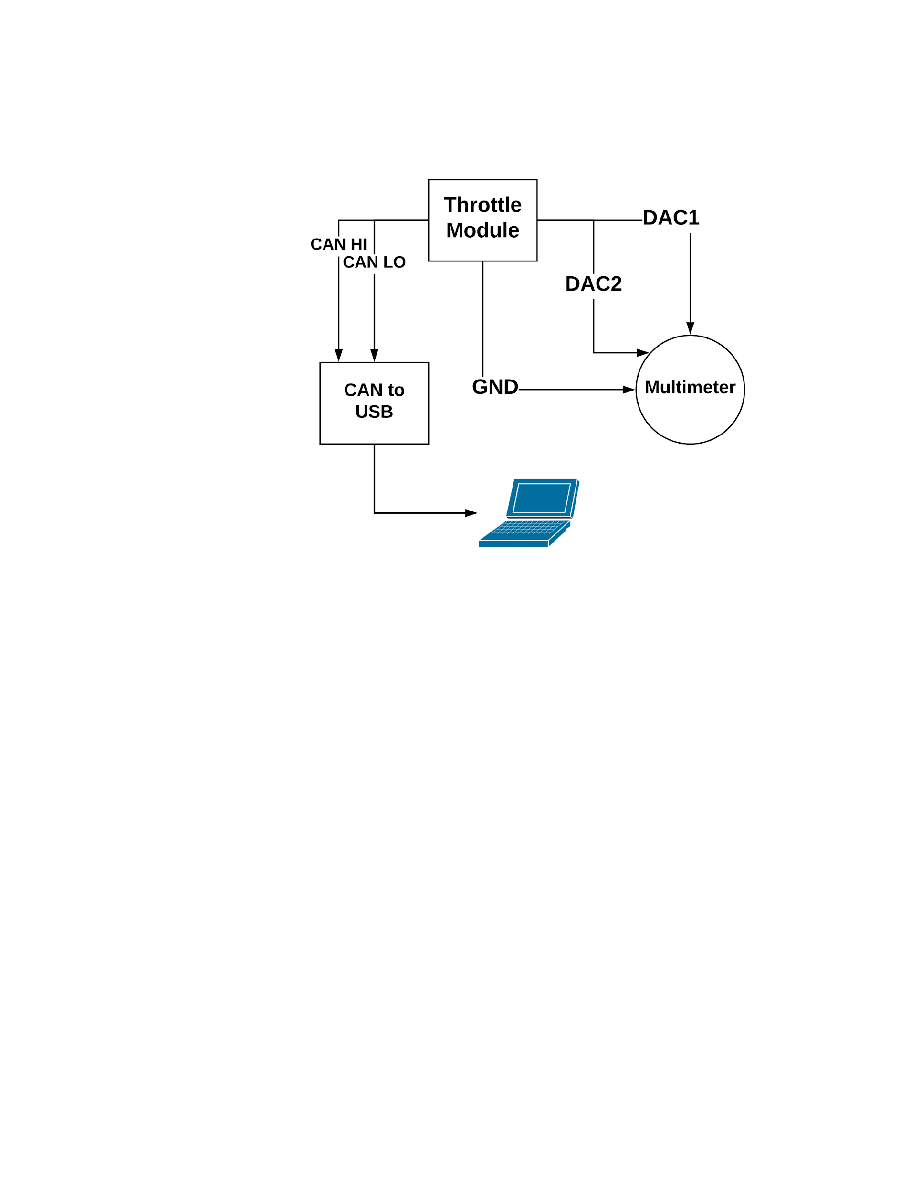

**Figure 2.2.1** - Throttle Module Test Setup - Static Test

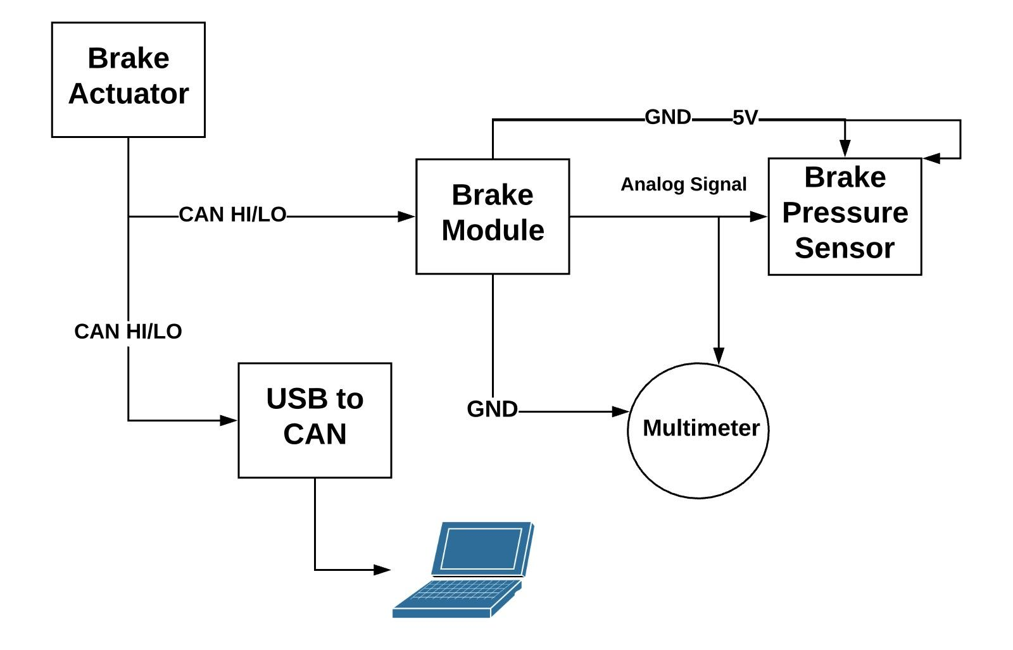

**Figure 2.2.2** - Brake Module Test Setup - Static Test

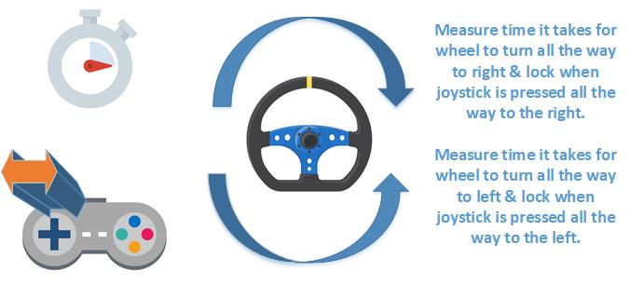

**Figure 2.2.3** - Steering Module Test Setup - Static Test

* **Test Data Log:**An Excel spreadsheet contains the response times of the modules and relevant voltages. Analysis of the times will indicate whether transmission and execution time meets requirements. We also logged behaviors of the vehicle to ensure they match joystick commands.

**2.2.2 Test Environment and Conditions:** The system was developed in a laboratory environment during this project. It was not be exposed to significant temperature changes, vibration, noise, or impact.

**2.2.3 Input Data Set:** The input data set was the CAN messages sent by the joystick (to check DbW system functionality) and a CAN-to-USB tool which will be operated by a tester.

**2.2.4 Expected data values and results:**Expected data is voltages and CAN messages. Input through the joystick and CAN to USB tool should produce specific effects in each of the other modules. Response time was be measured quantitatively with an oscilloscope while actuation is executed.

**2.2.5 Test Case Summary Data Analysis:** The following outlines the performance of our project during testing of the vehicle under normal driving conditions.

* **Summarize data logs:** The static test addressed the three main Drive-by-Wire functions listed in the requirements: Throttle, Brakes, and Steering. All three of these functions were tested with both qualitative and quantitative criteria. Once again, the digital oscilloscope was used to measure time and voltage levels on the sensors within the vehicle.
  + **Throttle**: For throttle function, we initialized the digital oscilloscope to take voltage measurement from the DAC inside the vehicle. The output was displayed on the Waveforms software and probes provided by the software were used to record time change. Below is an example of the measurement taken: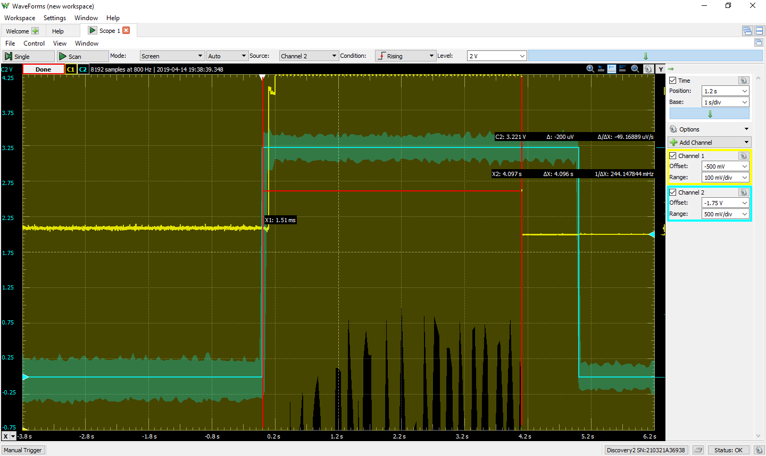

**Figure 2.2.4:** Sample Output of Throttle Pressure Sensor (Yellow) and CAN trigger (Blue)

Once the CAN message is sent, it takes only a short amount of time to reach full actuation as displayed above. The total time is taken when the DAC voltage reaches the experimental steady-state value of 2.101V which is established by the hardware inside the vehicle. Latency was also measured in this software and it remained consistently 100ms (total time for CAN message to be received as established in the programming and our requirements. One last factor that had not been accounted for was the lack of resistance on the wheels while the vehicle is on jack stands. Because the test is static, the throttle will take less time while the tires are floating than it would if driving on a road. The mean and standard deviation of the time to full throttle is displayed in the following table:

|  |  |  |
| --- | --- | --- |
|  | **Mean** | **Standard Deviation** |
| **Vehicle Throttle Time (s)** | 4.1812 | 0.1652 |
| **Latency (ms)** | 100 | 0 |

**Table 2.2.1:** Mean and Standard Deviation - Throttle Measurements

* + **Steering:** For steering functionality, we again set up the digital oscilloscope. In this case, however, to monitor the time to fully steer left and right, we utilized a built-in LED on the joystick board. Once our deadman switch was pressed, which disallows Drive-by-Wire commands unless pushed, an LED comes on. To complete this test, the tester pressed the joystick all the way right or left and then hit the deadman. This then triggers the oscilloscope and records while the steering wheel turns to its furthest angle. At that point, the deadman is released and th time is recorded. An example of this measurement is shown in the following image: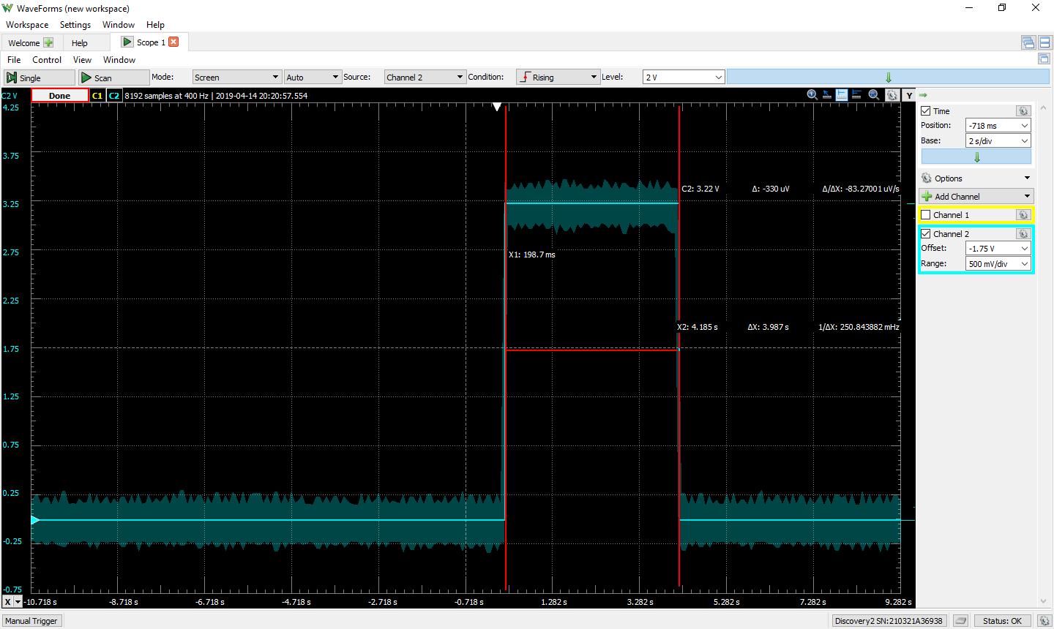

**Figure 2.2.5:** Sample Output of CAN trigger (Blue) for Steering Test

Since the vehicle design did not allow access to the torque sensor, this measurement is the best possible quantity to validate our steering function. Our requirement specification listed an approximate complete turn in about 4 seconds in one direction. This test was repeated for both left turn and right turn function. The results of our tests are shown in Table 2.2.2.

|  |  |  |
| --- | --- | --- |
|  | **Mean** | **Standard Deviation** |
| **Steering 0-100% Right (s)** | 3.9562 | 0.1887 |
| **Steering 0-100% Left (s)** | 3.9402 | 0.1617 |

**Table 2.2.2**: Mean and Standard Deviation of Steering Turn Time Measurement

* + **Brakes:** Lastly, for the brake test, the brake pressure sensor was connected to the digital oscilloscope in the same manner as the Emergency stop test. The brake will be triggered by joystick commands, held until it hits steady state and released. Full actuation of the brakes, based on the requirements, should take between 2 and 3 seconds from CAN message send. It should be noted that the linear actuator causes mechanical flex while actuating the brake. As such, the steady state condition varies as the linear actuator moves away and the brake board senses a reduction in pressure. Also, as the brakes got warmer, their grip on the wheels improved, slowing the overall stop time. The following image is a sample for the brake measurement from the oscilloscope:

**Figure 2.2.6:** Sample Output of BPS Voltage (Yellow) and CAN trigger (Blue) for Brake Test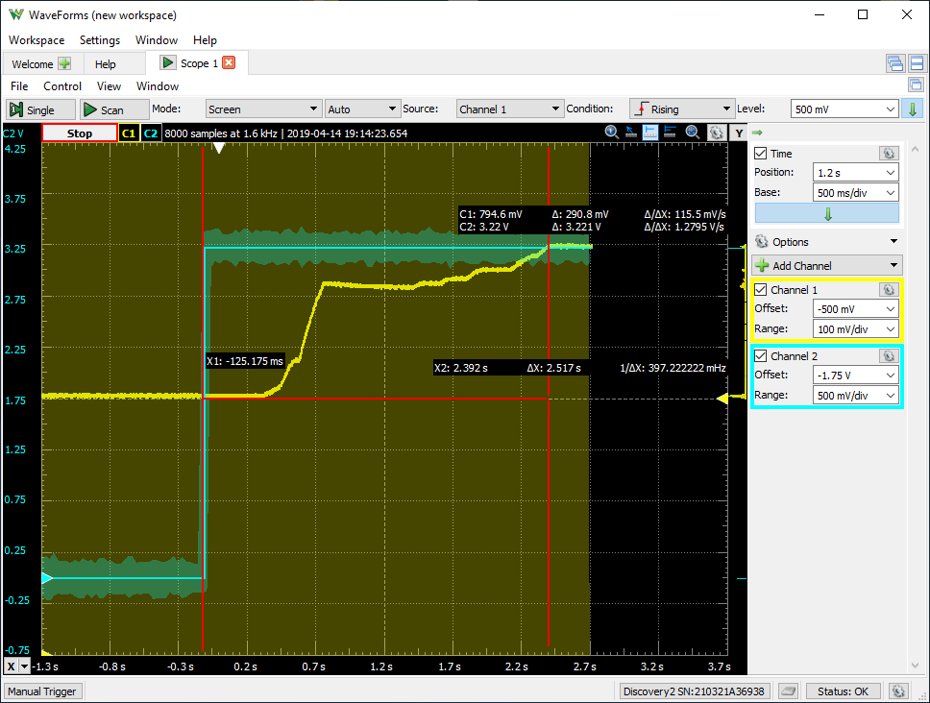

The following table summarizes the results of our brake test:

|  |  |  |
| --- | --- | --- |
|  | **Mean** | **Standard Deviation** |
| **Full Actuation Time (s)** | 1.9908 | 0.2528 |
| **BPS Voltage (mV)** | 772.61 | 17.032 |

**Table 2.2.3:** Mean and Standard Deviation for BPS Voltage and Full Actuation Time

The following graph outlines the consistency of our actuation times for all modules:

**Figure 2.2.7:** Actuation Times for Each Module in Static Test - Consistency Check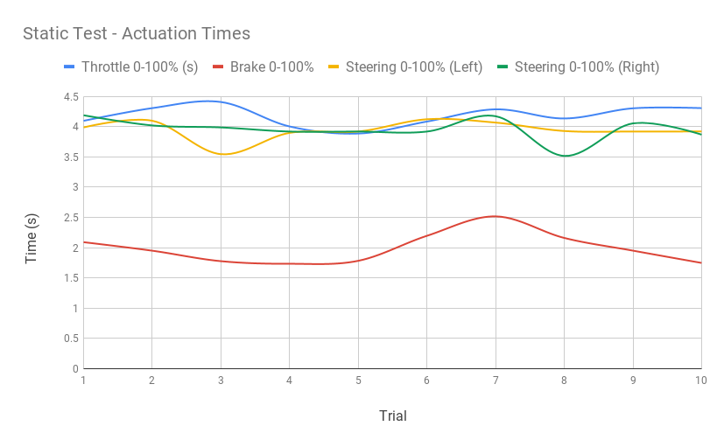

As displayed, our actuation times remained very consistent. The brakes did take less time to actuate after a few test cases and then did slow again after waiting a few minutes to conduct another trial.

* **Anomaly Report:** No anomalies were recorded during this test.
* **Suspension of Test:** Suspension criteria were not met while completing this test.

**2.2.6. Test Case Analysis**

Overall, these tests were very successful. All vehicle functions could be controlled from the joystick with no interruption or error.

|  |  |  |  |
| --- | --- | --- | --- |
| **Data Type** | **Test Criteria** | **Test Data Result** | **Rating (Excellent, Good, Minimum Satisfactory**  **Failure)** |
| Latency | Mean Time | ≤100msec | Excellent |
| Full Steering Turn Time | Mean Time | ≤4sec | Excellent |
| Full Brake Actuation Time | Mean Time | TBD* | TBD* |
| Full Throttle Actuation Time | Mean Time | TBD* | TBD* |

* Upon completion of testing we realized our test plan success criteria was flawed for our Static Test. We have all of the data ready, we just need to redesign the criteria and assign ratings for the data for the Final Draft of the Test Plan.

**2.3 Test Case 3** Pedestrian in Crosswalk

Traces to Requirements:

* DSRC requirements: 3.1.x
* Throttle requirements: 3.2.x
* Steering requirements: 3.3.x
* Brake requirements: 3.4.1-2, 3.4.4-8
* Power requirements: 3.6.1, 3.6.2
* Timing requirements: 3.7.1,3.7.2,3.7.3

**2.3.1. Test Case Summary:** The purpose of this test case was to test operating behavior of the DSRC radios and the onboard modules. In this test, we used a laptop to send a UDP message to the RSU radio. The RSU radio then generated and sent a DSRC message to the OBU indicating a pedestrian in a “crosswalk”. When the OBU received the DSRC message, it should generate and send a CAN message that when received by the drive-by-wire modules, alters the states of the modules causing the vehicle to enter safe mode. The brake module should provide full brake in this safety mode and all other modules should not react to control messages until this mode of operation is lifted. This test case will ensure that the system behaves as desired under ideal conditions. This means that the following criteria are true:

* Laptop will send a UDP message to RSU radio and generate a DSRC message
* A message of a pedestrian in the crosswalk will be received by OBU
* Joystick will be commanding throttle module to full throttle
* No lack of control messages between modules being sent
* E-Stop will not be pressed
* No input torque applied to the steering wheel by the driver or pressure on brake pedal

The vehicle was operated by the joystick with all of the above conditions being met.

* **Test Initialization**:

1. Have the vehicle on jacks (Static Test discussed above)
2. Connect USB-to-CAN device to vehicle CAN bus
3. Configure a laptop to read the CAN bus (Baud rate & channel)
4. Setup the RSU DSRC radio & open UDP socket via another laptop
5. Unplug the vehicle from charging port.
6. Turn the vehicle on.
7. Turn on Drive-by-Wire & OBU on and verify functionality
8. Apply full throttle via joystick and hold during the test

* **Test Steps:** Once the vehicle is on initialization step 8, we will do the following task:

1. Send UDP socket message to the road side unit.
2. Verify the RSU is generating & sending the DSRC message.
3. Check the vehicle stops when “pedestrian in crosswalk” is sent.
4. Try to control the vehicle with the joystick and verify it is in safety mode.
5. Verify all data was logged properly.
6. Repeat 10 times and average the amount of time it takes for the vehicle to stop.
7. If the system operates as expected, using the logged data perform calculation and report the data.

* **Test Data Log:**Data is collected using a USB-to-CAN device. The CAN message generated when OBU is signaled by RSU is logged onto Excel. The DSRC distance will also be noted as well as the time it takes for the vehicle to stop after reception of the original DSRC message.

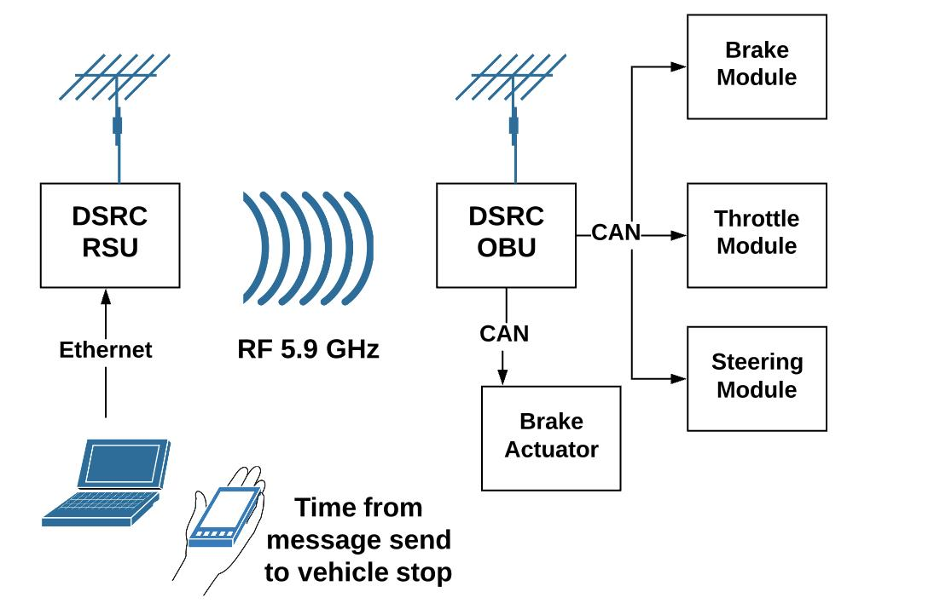

**Figure 2.3.1** - The RSU will alert OBU of pedestrian in crosswalk. OBU sends appropriate CAN messages to all modules.

**2.3.2. Test Environment and Conditions:** The system will be developed in a laboratory environment during this project. It will not be exposed to significant temperature changes, vibration, noise, or impact.

**2.3.3. Input Data Set:** The DSRC module of the system will be tested at less than a distance of 100 ft with clear line of sight. A UDP socket message will send the message from the laptop to the road side unit. The message will be made into a DSRC message and sent by the RSU to the OBU indicating a pedestrian in a “crosswalk”. The received DSRC message by the OBU will generate a CAN message that, when transmitted and received by the respective modules, will alter the states of the modules causing the vehicle to enter safe mode.

**2.3.4. Expected data values and results:** The expected data is a CAN message signaling the vehicle to slow to a stop based on the radio’s position. The vehicle should stay in front of the pedestrian walkway within the prescribed stoppage time, after which normal DbW operation will resume.

**2.3.5 Test Case Summary Data Analysis:** The following outlines the performance of our project during testing of the vehicle normal driving conditions.

* **Summarize data logs:** To complete this test, we set up a digital oscilloscope connected to a computer. Using the Waveforms software, the voltage from the Brake Pressure sensor could be captured in real time. Our requirement specification dictates that the distance between the two radios needed to be less than 100ft. As such, we set the RSU at approximately 80ft from the OBU. The measurement was taken from the start of the brake pressed to reaching steady state:

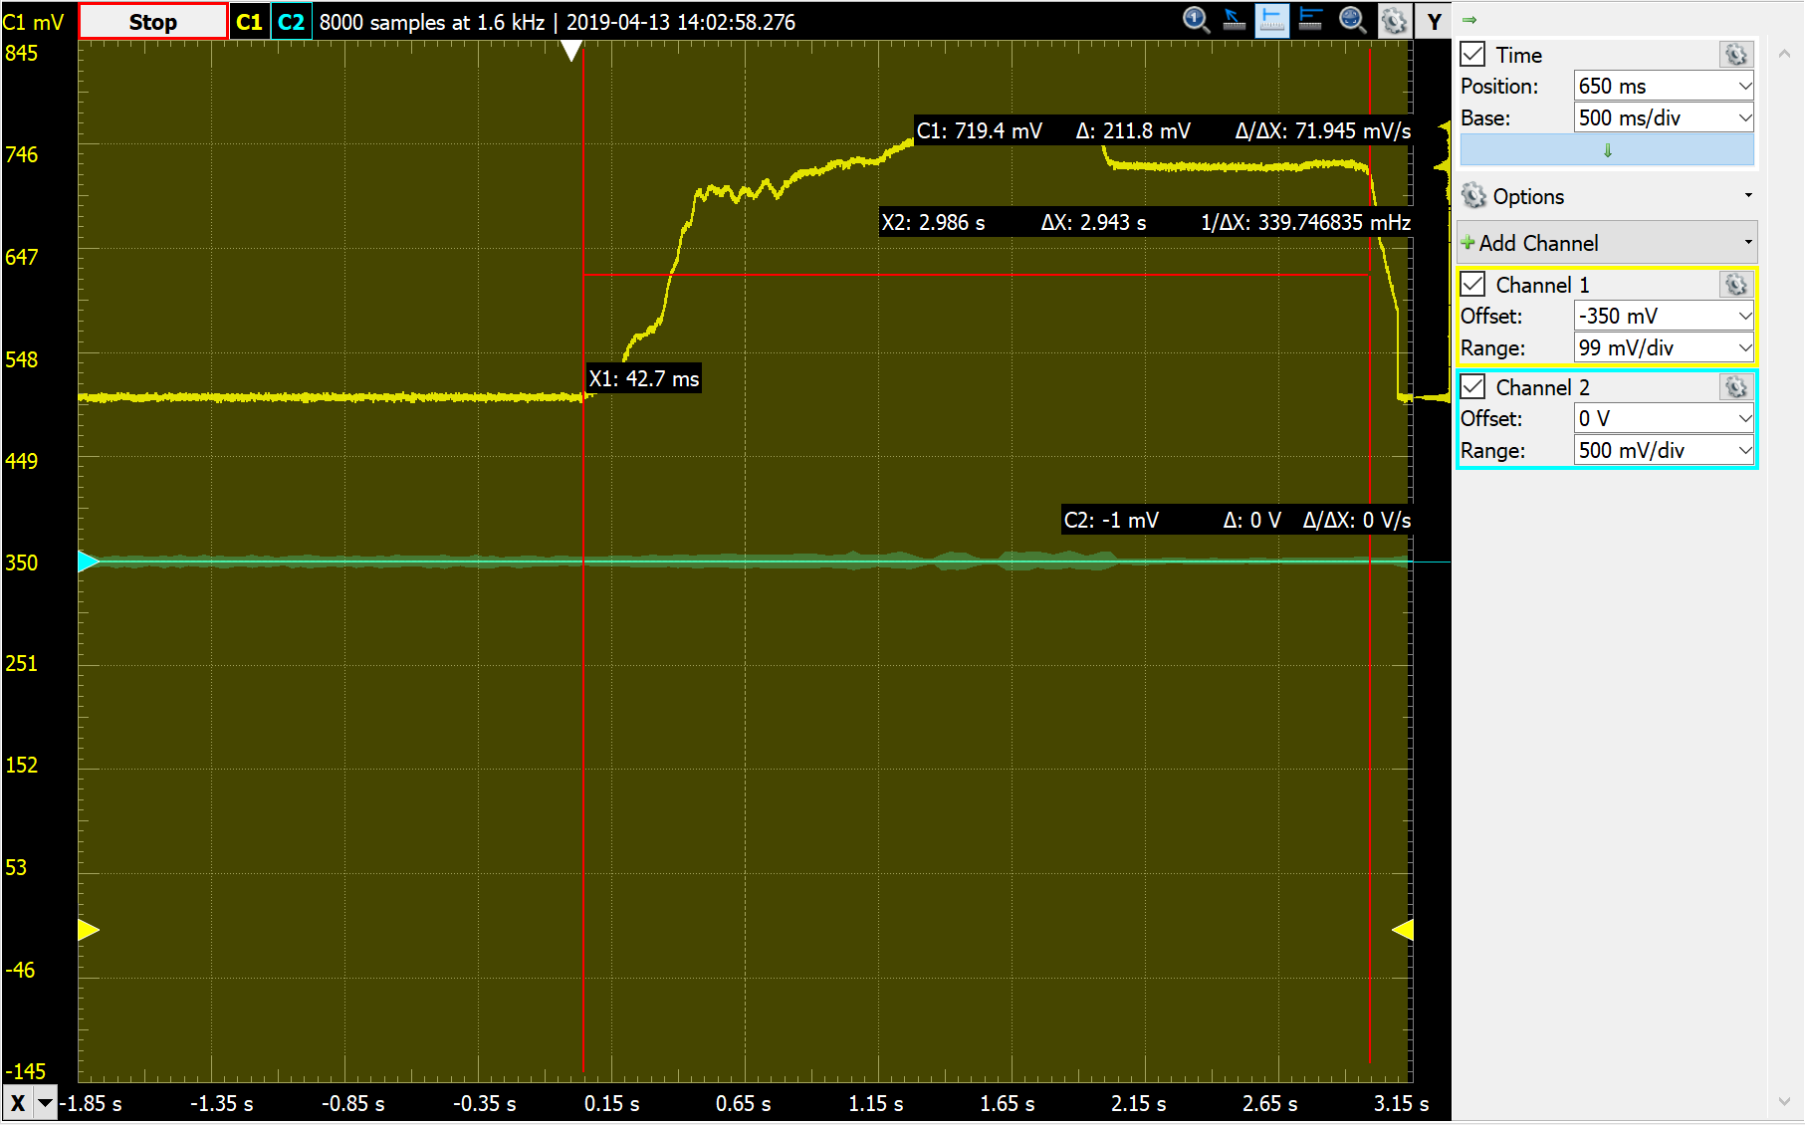

**Figure 2.3.2**: Sample capture of BPS voltage during DSRC control

The summary of all measurements taken is displayed in the following table:

|  |  |  |
| --- | --- | --- |
|  | **Mean** | **Standard Deviation** |
| **Vehicle Stopping Time (s)** | 1.8095 | .0485 |
| **Latency (ms)** | 2.8044 | .6826 |

**Table 2.3.1**: Mean and Standard Deviation of DSRC Measurement Criteria

The consistency of our results can be displayed using a graph shown below:

**Figure 2.3.3:** Graph of Vehicle Stop Time after DSRC Message - Consistency Check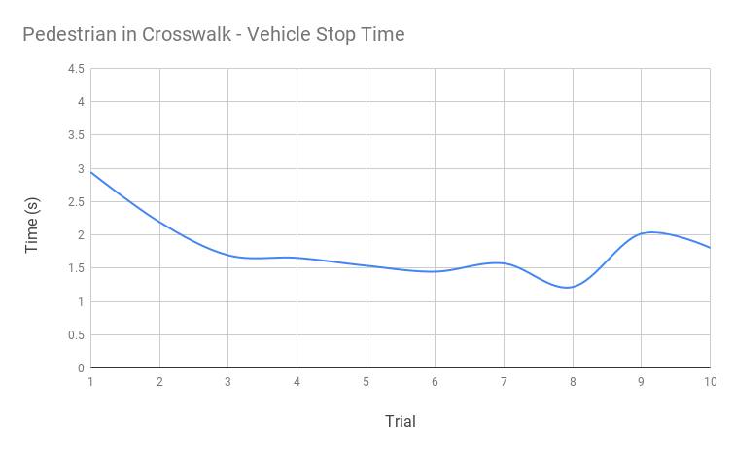

As displayed, the general trend of trigger time to full actuation actually decreases with each test, similar to the static test. This is because the brakes begin to heat up, increasing grip and, thus, reducing the time needed to completely stop the wheels from spinning.

* **Anomaly Report:** Early trials showed inconsistent timestamps between the OBU and RSU. This was resolved by calibrating the antenna of the RSU. Preventing this separation may take further investigation/interchanging of radios.
* **Suspension of Test:** First run of this test was suspended due to a demonstration conducted by research team. Connection of imaging system disrupted DSRC. After resuming the test following the demo, suspension criteria were never met. As such, this test was successful.

**2.3.6. Test Case Analysis**

Our requirement specification listed that when a DSRC message is received, the vehicle should stop within 2-3 seconds, accounting for the lack of friction with the testing conditions. Our defect severity criteria also took into account the improved braking efficiency as thermal energy increases. Based on these results, our system meets this requirement well.

|  |  |  |  |
| --- | --- | --- | --- |
| **Data Type** | **Test Criteria** | **Test Data Result Result** | **Rating** |
| Stopping Time | Mean total time | <2.5s | Excellent |

**2.4 Test Case 4** No Control Messages Being Sent

Traces to Requirements:

* Throttle requirements: 3.2.4
* Steering requirements: 3.3.2
* Brake requirements: 3.4.3
* Timing requirements: 3.7.1-3

**2.4.1. Test Case Summary:** The purpose of this case was to test if the vehicle appropriately disengages DbW mode when at least 3 consecutive messages fail to be received by a module or are corrupted. This test case will ensure that the system behaves as desired under ideal conditions and will act appropriately if CAN subsystem fails. This means that the following criteria are true:

* No message of a pedestrian in the crosswalk from the RSU
* No messages being sent from the joystick or improper signal is generated
* No control messages sent between modules via CAN
* E-Stop will not be pressed

The vehicle will be controlled with the joystick before communication is disrupted.

* **Test Initialization:**
  1. Unplug the vehicle from charging port.
  2. Turn the vehicle on.
  3. Put vehicle on jacks.
* **Test Steps:** Once the vehicle is on initialization step 3, we will do the following tasks:

1. Send control signals using joystick.
   1. Before completing this test, normal operating conditions must be established of the DbW system. This will be a shorter version of the second test case so that every time the joystick is disconnected there are no other issues that arise within the system.
2. Disconnect joystick board, brake actuator, steering actuator and disable the feedback messages.
3. Repeat 30 times to make sure DbW always disengages and then can be re-engaged one connections are re-established and vehicle power is cycled.
4. Testing will be done on a pass/fail basis per the human error that is introduced in disconnecting the DB9 or CAN H/ CAN L.
5. Once thest test has concluded, we will reconnect the actuators & enable the feedback messages.

* **Test Data Log**:The data log will consist of qualitative confirmation of the disengage message if 3 consecutive CAN messages are missed, on a PASS/FAIL basis.

**Figure 2.4.1 -** Break communication between the Joystick microcontroller and all other microcontrollers to test message Rx failure behavior.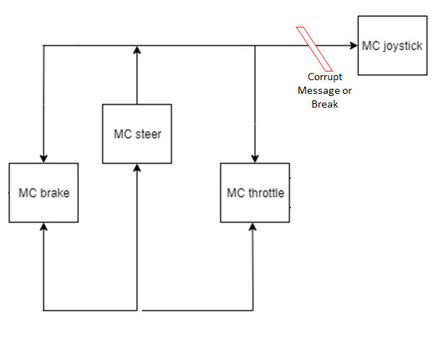

**2.4.2. Test Environment and Conditions**: The system was developed in a laboratory environment during this project. It was not exposed to significant temperature changes, vibration, noise, or impact.

**2.4.3. Input Data Set:** The vehicle was initially controlled as listed in test case 2. Control will be halted suddenly by disconnecting the joystick or another CAN line to simulate messages failing to consecutively send. Actuators will be disconnected such that they are not feeding back onto the CAN bus & DbW feedback messages will be disabled.

**2.4.4. Expected data values and results:** Expected data value is this will never fail, timing will not be possible for this to be done a system test level because of the redundancy systems that are currently in place.

**2.4.5. Test Case Summary Data Analysis:** Passed all 30 attempts

* **Summarize Data Logs:** The LED turns red when we disconnect CAN lines within 300 ms, but because of the human error associated with disconnecting the CAN lines the results were not in anyway reportable.
* **Anomaly Report:** Human error of pulling the Db9 connector out of the boards.
* **Suspension of Test:** If this test fails even once, we will postpone testing & resolve the issue. After the issue is resolved we will restart the test from the beginning and try again.

**2.5 Test Case 5** Steering Input Torque Override

Traces to Requirements:

* Steering requirements: 3.3.4
* Timing requirements: 3.7.1-3

**2.5.1. Test Case Summary:** The purpose of this case was to test that the vehicle disengages DbW mode in the event the wheel input torque exceeds ±7Nm and control reverts back to manual. This test case will ensure that the system behaves as desired under ideal conditions. This means that the following criteria are true:

* No message of a pedestrian in the crosswalk from the RSU
* No lack of messages being sent from the joystick
* No lack of control messages between modules being sent
* E-Stop will not be pressed

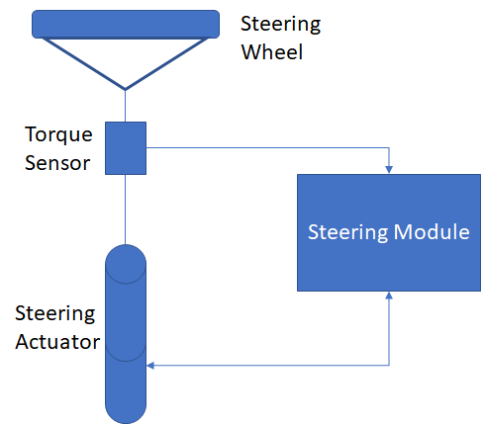

**Figure 2.5.1** - Steering components whose operation will be checked in this test case.

* **Test Initialization**:

1. Unplug the vehicle from charging port.
2. Put the vehicle on jacks for a static test.
3. Turn the vehicle on.
4. Have one tester using the joystick to control the vehicle.
5. Have test driver ready to turn the steering wheel.

* **Test Steps:** Once the vehicle is on initialization step 5, we will do the following tasks:

1. Turn the steering wheel via the joystick.
2. Test driver turns the steering wheel to trigger the steering module to disengage DbW.
3. Read the value on the electronic and, then calculate and record the value in Nm.
4. These steps will be repeated 10 times to generate an average amount of force required to cut out DbW.

* **Test Data Log:**The input torque sensor outputs from the electronic balance and if the vehicle successfully disengaged DbW mode once it exceeds ±7Nm. This will be iterated several times to create an average.

**Figure 2.5.2** - Steering Torque Measurement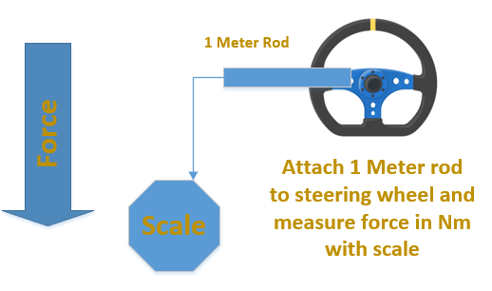

**2.5.2. Test Environment and Conditions:** The system was developed in a laboratory environment during this project. It was not exposed to significant temperature changes, vibration, noise, or impact.

**2.5.3. Input Data Set:** The input steering torque has to remain under a certain threshold to indicate it is not being manually overridden. This was ensured by testing that the DbW system was active and functional before conducting each trial. This was accomplished by turning the steering wheel with the joystick.

**2.5.4. Expected data values and results:**The expected data type is a measurement in Nm that exceeds ±7Nm. The vehicle is expected to disengage DbW mode past that certain torque threshold which is consistent with a person turning the wheel.

**2.5.5 Test Case Summary Data Analysis:** The following outlines the performance of our project during testing:

* **Summarize data logs:** To complete this test, we set up the test environment with a 1-ft metal rod attached to the steering wheel of the vehicle and the digital scale attached to the end of the rod. The steering wheel was turned completely to the right using the joystick and the meter was pulled up on until DbW disengaged. The ft-lbs measured were then converted to Nm. Our requirement specification dictates that the override should not be activated unless the torque exceeded ±7Nm. The actual test set-up is shown in Figure 2.5.3:

**Figure 2.5.3:** Actual Test Setup - Steering Torque Override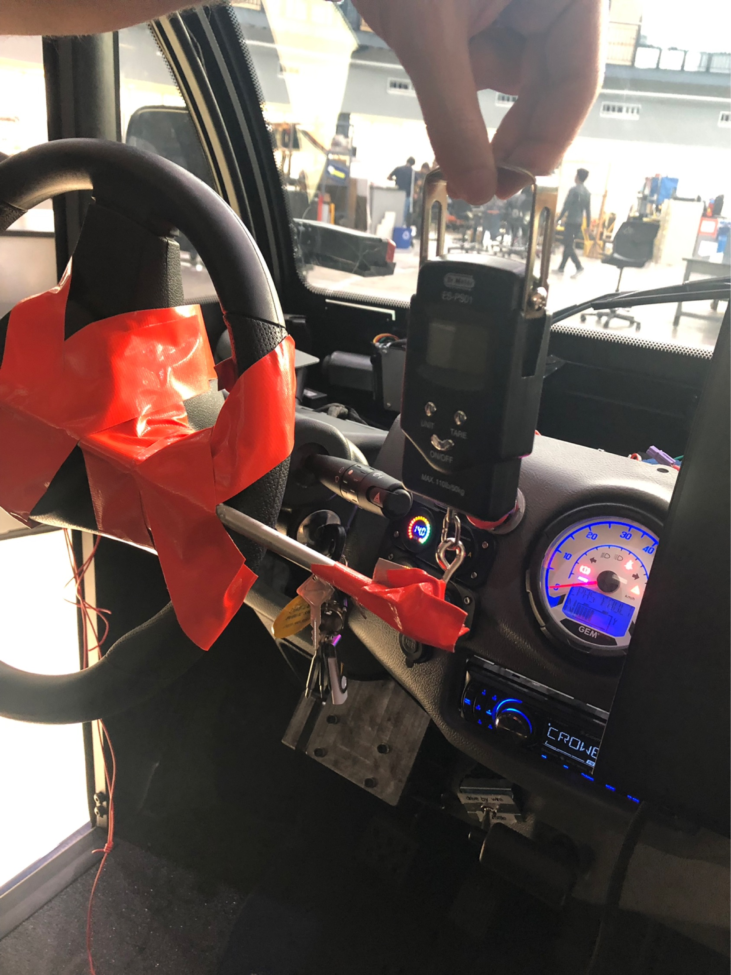

The following table outlines the mean and standard deviation of our test measurements

|  |  |  |
| --- | --- | --- |
|  | **Mean** | **Standard Deviation** |
| **Torque Input (Nm)** | 8.62975 | 0.297697 |

**Table 2.5.1:** Mean and Standard Deviation - Input Torque

* **Anomaly Report:** No anomaly was observed with this test. The steering override functions as intended and required.
* **Suspension of Test:** Suspension of this test was not required.

**2.5.6. Test Case Analysis**

This project required that a specific torque threshold be exceeded in order to disengage Drive-by-Wire immediately. This test confirmed that we met this requirement and no less torque would inadvertently disengage DbW.

|  |  |  |  |
| --- | --- | --- | --- |
| **Data Type** | **Test Criteria** | **Test Data Result Result** | **Rating** |
| Torque Input | Mean torque measurement | ≥|7Nm| | Excellent |

**3. Test Report Summary**

**3.1 Summarize Overall Test Results**

|  |  |  |  |
| --- | --- | --- | --- |
| **Test Case No.** | **Test Case Name** | **Test Case Result** | **Rating** (Excellent, Good, Minimum Satisfactory  Failure) |
| 1 | E-Stop Test | 80% within 2sec - 2.5sec | Excellent |
| 2.1 | Static Test - Brake | TBD * | TBD * |
| 2.2 | Static Test - Throttle | TBD * | TBD * |
| 2.3 | Static Test - Steering | TBD * | TBD * |
| 3 | Pedestrian in Crosswalk | 90% under 2.5sec | Excellent |
| 4 | No Control Messages | Pass** | Pass** |
| 5 | Steering Input Torque Override | 100% ≥|7Nm| | Excellent |

* Upon completion of testing we realized our test plan success criteria was flawed for our Static Test. We have all of the data ready, we just need to redesign the criteria and assign ratings for the data for the Final Draft of the Test Plan.

** Similar to above, we need to re-do our success criteria in order to account for the test becoming pass/fail.

**3.2 Path Forward**

After completion of our testing we were pleased to see that for 3 of the 5 test cases we achieved excellent results. For the remaining two test cases (Static Test and No Control Message test), we do have a small amount of work to do before our final draft. For the Static Test, we realized during testing that our criteria for success didn’t align well with our requirements. While we gathered data and plotted/found averages and standard deviations, we need to develop new success criteria to assess whether the results were excellent or not. This will be done by reevaluating our requirements specification. We expect all of our test results to be in the excellent or good region.

For the No Control Messages test, we realized we could only get a Pass/Fail result. While trying to perform the test, we quickly realized that due to all of the redundant safety systems in the vehicle and the human error associated with disconnecting all of the CAN lines in the system at the same time, the data would be inconsistent. Instead we just decided to test whether or not the system behaved safely when CAN communication was ceased. We will need to fix the table in 3.1 for this reason before the final draft of this document.

**4. References:**

[1] System Requirements Specification

[2] System High Level Design Specification

[3] System Low Level Design Specification

[4] System Test Plan

[5] Test Report Data